**Pseudocode for FieldView**

Recap: This is a mobile app designed for researchers who often conduct field research and need to collect and store data in an easy and quick way. There will be two activities in this app, one is the home screen for data storage and display, the other is the add data screen.

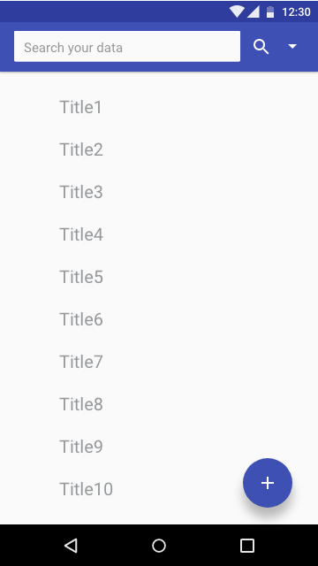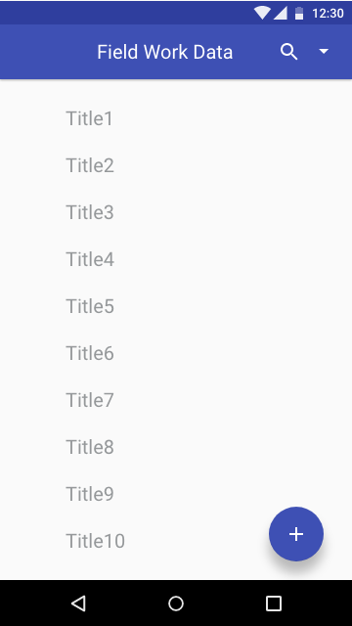

A

**Home Screen Search Bar**

This the home screen, the main activity where all the data will be displayed and editable. By clicking the right bottom button, the user will be led to another screen to add the data. To realize this, a new xml file along with a new java class will be created. And an Intent will be used in the MainActivity.java to start the new activity. On the top of the screen, there is a search button quick search among all the data inserted and displayed on the screen. I’ll use the online open source search view library from

<https://github.com/MiguelCatalan/MaterialSearchView>,

And make a reference to this tutorial:

<https://www.youtube.com/watch?v=FZfjWXYm80k>.

All the data shown here should be clickable and editable, by clicking the data itself, the user would be able to get to its original adding data page.

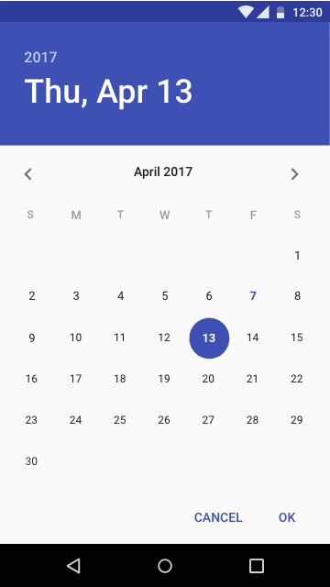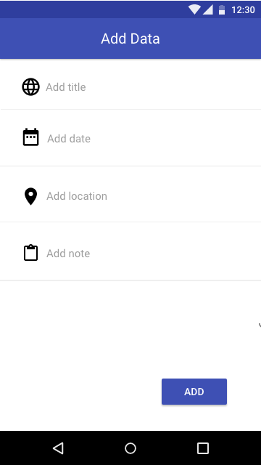

**. Add Data Calendar**

This is the add data screen, the other activity I’ll use to help

the user to add their data. Features displayed are two textfields which allow the user to add title and notes, a calendar view that allows the user to add or modify the date, and a location tracking that gets the real-time

GPS location of the user.

For the calendar, I’ll use the DatePickerDialog class and its OnDateSetListener method. Make a reference to this tutorial:

<https://www.youtube.com/watch?v=hwe1abDO2Ag>

For the location tracking part, I’ll use the Location Manager and Location Listener with a online tutorial reference:

<https://www.youtube.com/watch?v=QNb_3QKSmMk>

Also, will integrate what we’ll learn about location in class on Nov 28.

All the data should be manageable by a SQLite database. I’ll create a DBOpenHelper class and extends the SQLiteHelper class to create a local database. Then implement the ContentProvider class to make the database manageable.

Make a reference to this tutorial:

<https://www.youtube.com/watch?v=aQAIMY-HzL8>